**Jalu Chaudhary**

**Class IT_314_DL1  
Hand on assignment: Cursors and Exception Handling**

**Assignment 4-9: Using an Explicit Cursor**

Create a block to retrieve and display pledge and payment information for a specific donor. For

each pledge payment from the donor, display the pledge ID, pledge amount, number of monthly

payments, payment date, and payment amount. The list should be sorted by pledge ID and then

by payment date. For the first payment made for each pledge, display “first payment” on that

output row.

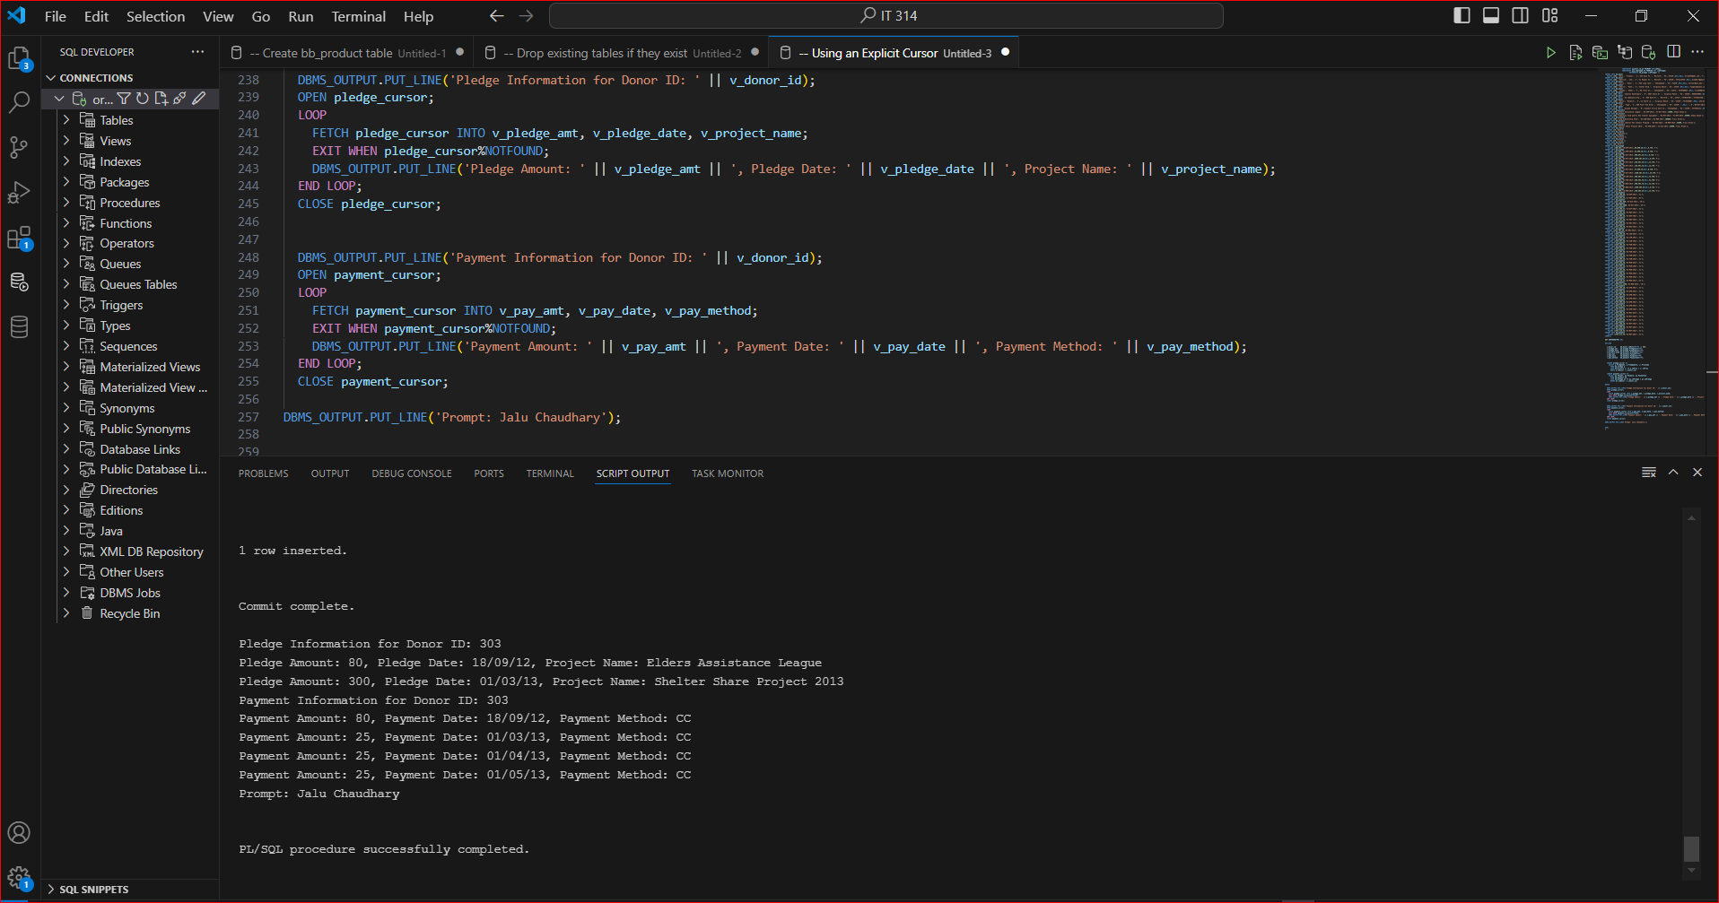

**Assignment 4-10:** Using a Different Form of Explicit Cursors Redo Assignment 4-9, but use a different cursor form to perform the same task

